## What is SQL?

Structured Query language (SQL) **pronounced as "S-Q-L" or sometimes as "See-Quel**" is the standard language for dealing with Relational Databases. A relational database defines relationships in the form of tables.

SQL programming can be effectively used to insert, search, update, delete database records.

That doesn't mean SQL cannot do things beyond that. It can do a lot of things including, but not limited to, optimizing and maintenance of databases.

Relational databases like MySQL Database, Oracle, Ms SQL Server, Sybase, etc. use SQL

## What is NoSQL?

NoSQL is a non-relational DMS, that does not require a fixed schema, avoids joins, and is easy to scale. NoSQL database is used for distributed data stores with humongous data storage needs. NoSQL is used for Big data and real-time web apps. For example companies like Twitter, Facebook, Google that collect terabytes of user data every single day.

NoSQL database stands for "Not Only SQL" or "Not SQL." Though a better term would NoREL NoSQL caught on. Carl Strozz introduced the NoSQL concept in 1998.

## Difference between SQL and NoSQL

|  |  |  |
| --- | --- | --- |
| **Parameter** | **SQL** | **NOSQL** |
| Definition | SQL databases are primarily called RDBMS or Relational Databases | NoSQL databases are primarily called as Non-relational or distributed database |
| Design for | Traditional RDBMS uses SQL syntax and queries to analyze and get the data for further insights. They are used for OLAP systems. | NoSQL database system consists of various kind of database technologies. These databases were developed in response to the demands presented for the development of the modern application. |
| Query Language | Structured query language (SQL) | No declarative query language |
| Type | SQL databases are table based databases | NoSQL databases can be document based, key-value pairs, graph databases |
| Schema | SQL databases have a predefined schema | NoSQL databases use dynamic schema for unstructured data. |
| Ability to scale | SQL databases are vertically scalable | NoSQL databases are horizontally scalable |
| Examples | Oracle, Postgres, and MS-SQL. | MongoDB, Redis, , Neo4j, Cassandra, Hbase. |
| Best suited for | An ideal choice for the complex query intensive environment. | It is not good fit complex queries. |
| Hierarchical data storage | SQL databases are not suitable for hierarchical data storage. | More suitable for the hierarchical data store as it supports key-value pair method. |
| Variations | One type with minor variations. | Many different types which include key-value stores, document databases, and graph databases. |
| Development Year | It was developed in the 1970s to deal with issues with flat file storage | Developed in the late 2000s to overcome issues and limitations of SQL databases. |
| Open-source | A mix of open-source like Postgres & MySQL, and commercial like Oracle Database. | Open-source |
| Consistency | It should be configured for strong consistency. | It depends on DBMS as some offers strong consistency like MongoDB, whereas others offer only offers eventual consistency, like Cassandra. |
| Best Used for | RDBMS database is the right option for solving ACID problems. | NoSQL is a best used for solving data availability problems |
| Importance | It should be used when data validity is super important | Use when it's more important to have fast data than correct data |
| Best option | When you need to support dynamic queries | Use when you need to scale based on changing requirements |
| Hardware | Specialized DB hardware (Oracle Exadata, etc.) | Commodity hardware |
| Network | Highly available network (Infiniband, Fabric Path, etc.) | Commodity network (Ethernet, etc.) |
| Storage Type | Highly Available Storage (SAN, RAID, etc.) | Commodity drives storage (standard HDDs, JBOD) |
| Best features | Cross-platform support, Secure and free | Easy to use, High performance, and Flexible tool. |
| Top Companies Using | Hootsuite, CircleCI, Gauges | Airbnb, Uber, Kickstarter |
| Average salary | The average salary for any professional SQL Developer is $84,328 per year in the U.S.A. | The average salary for "NoSQL developer" ranges from approximately $72,174 per year |
| ACID vs. BASE Model | ACID( Atomicity, Consistency, Isolation, and Durability) is a standard for RDBMS | Base ( Basically Available, Soft state, Eventually Consistent) is a model of many NoSQL systems |

[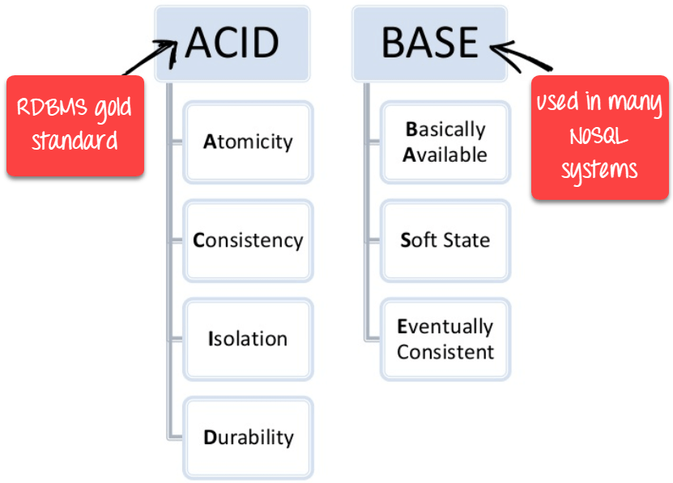](https://www.guru99.com/images/1/101818_0550_Differenceb2.png)

ACID vs BASE

**When to use SQL?**

* SQL is the easiest language used to communicate with the RDBMS
* Analyzing behavioral related and customized sessions
* Building custom dashboards
* It allows you to store and gets data from the database quickly
* Preferred when you want to use joins and execute complex queries

**When to use NoSQL?**

* When ACID support is not needed
* When Traditional RDBMS model is not enough
* Data which need a flexible schema
* Constraints and validations logic not required to be implemented in database
* Logging data from distributed sources
* It should be used to store temporary data like shopping carts, wish list and session data

**KEY DIFFERENCE**

* **SQL** pronounced as "S-Q-L" or as "See-Quel" is primarily called RDBMS or Relational Databases whereas **NoSQL** is a Non-relational or Distributed Database.
* SQL databases are table based databases whereas NoSQL databases can be document based, key-value pairs, graph databases.
* SQL databases are vertically scalable while NoSQL databases are horizontally scalable.
* SQL databases have a predefined schema whereas NoSQL databases use dynamic schema for unstructured data.
* SQL requires specialized DB hardware for better performance while NoSQL uses commodity hardware.